Operating Instructions of the C077 Swimming Pool Timer

- After carefully opening the box, fit the supporting feet as shown on the diagram below.
- The unit is now ready for use. It has been thoroughly tested in the manufacturing plant and has passed all Q.C. tests.
- To start and stop the unit, press the red button on the back of the unit.
- To reset the unit back to the 0 position, the minute hand can be adjusted by turning the knob on the back of the clock case. The second hand must be allowed to run normally until it reaches the 0 position.
- When the battery needs to be replaced, pull the blue knob off from its spindle at the back of the case. Unclip the small battery cover and remove the battery.
- Fit a fresh LR6 type alkaline battery in position, ensuring that the brass connecting piece is in position.
- Refit the back cover in position and push back on the hand adjuster onto its spindle.

Please note that the unit is splash proof and must not be immersed in water.

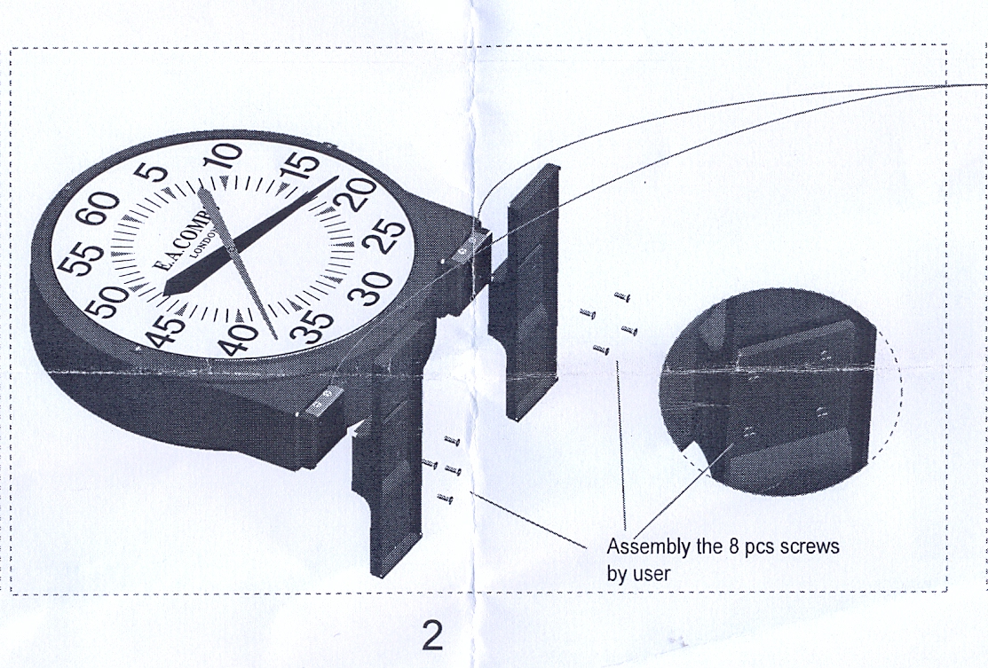

C077 instructions.doc

